**Video 37:**  
**Using BootStrap Scripts:**You can write the scripts directly in the step 3 of creating instance or you can browse for the script file. Below is a sample script which will run while starting the instance.  
!#/bin/bash  
yum install httpd –y  
yum update –y  
service httpd start  
chkconfig httpd on  
You can use AWS and other commands also in the script.  
If you have a script called index.html in the /var/www/html then, no need to give the script name in the browser URL. You can just give <http://IP-Address> of server is enough.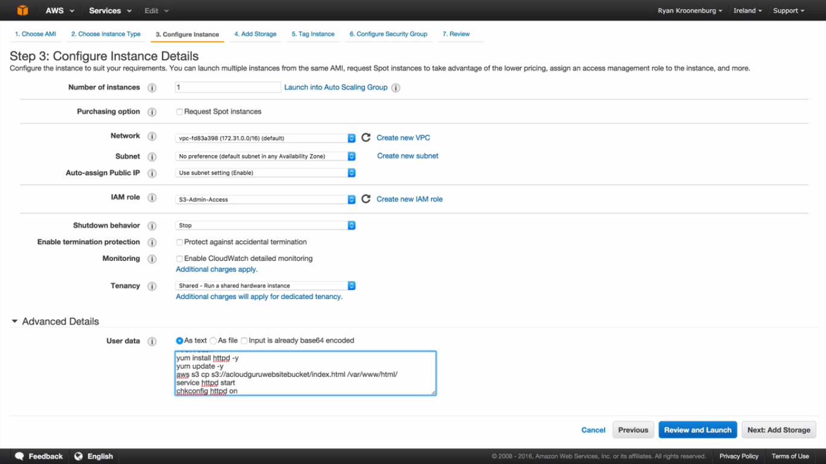

**Video 38:  
EC2 Instance Meta-data:**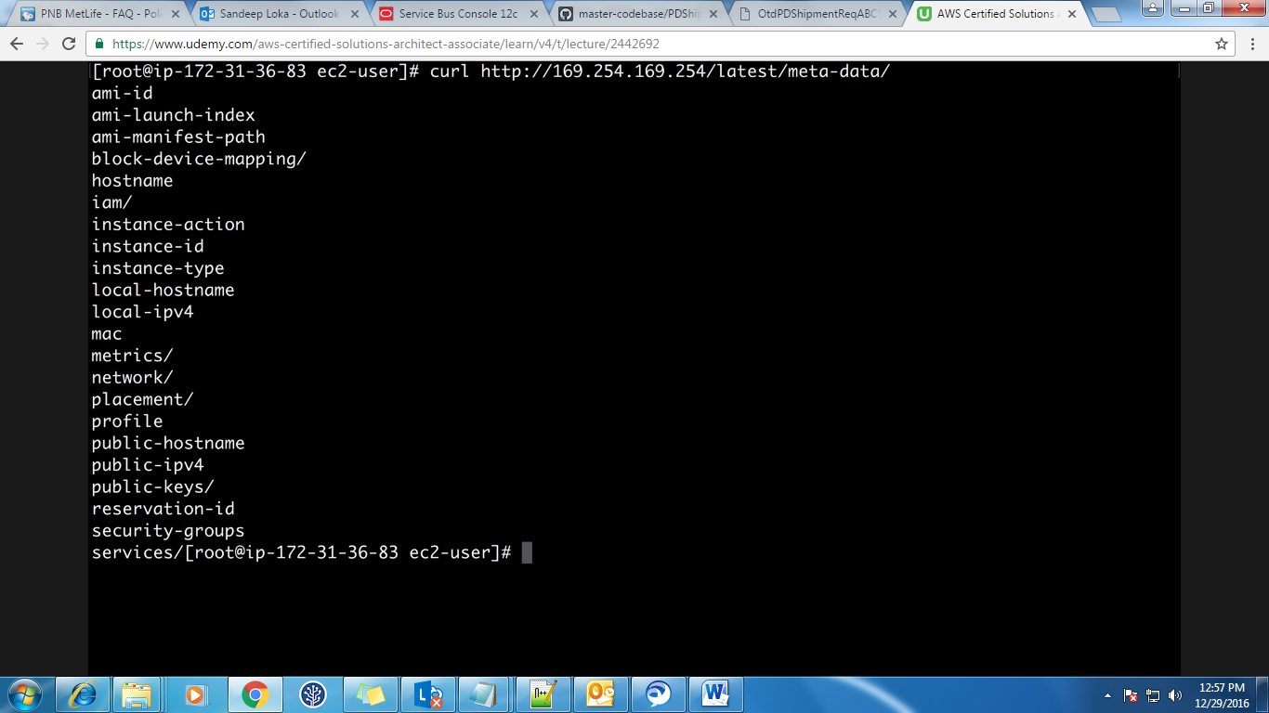If you want to check the public IP address of the current instance then just give the below command and if you want to write it to a file then issue > and file name.

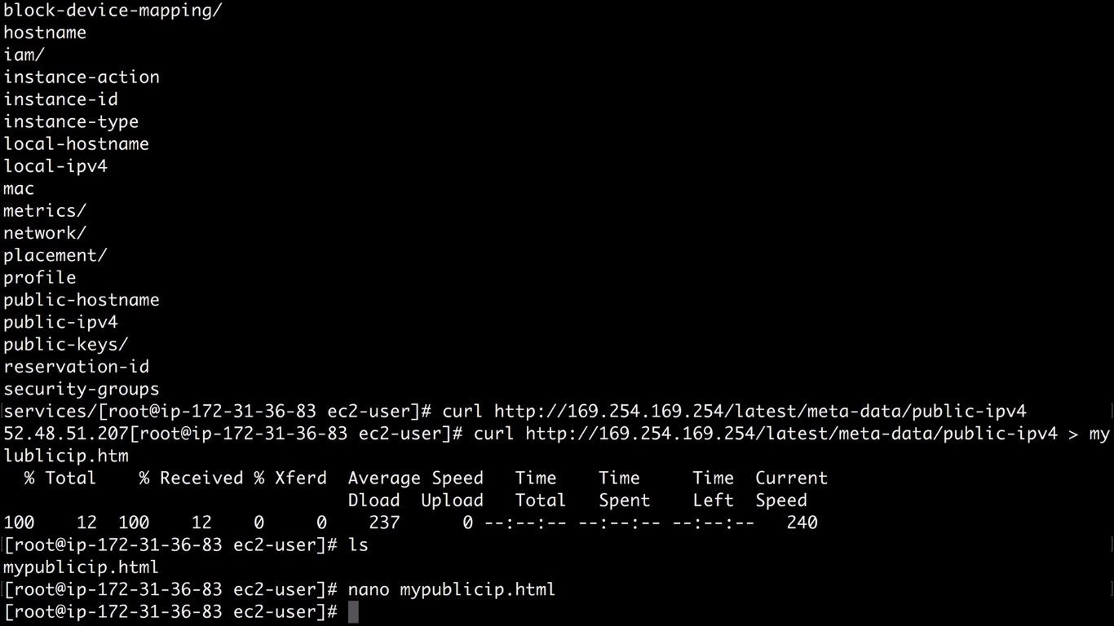

**Video 39:  
AutoScaling:**Click on Launch Configurations under Auto Scaling and then Create Autoscaling**.**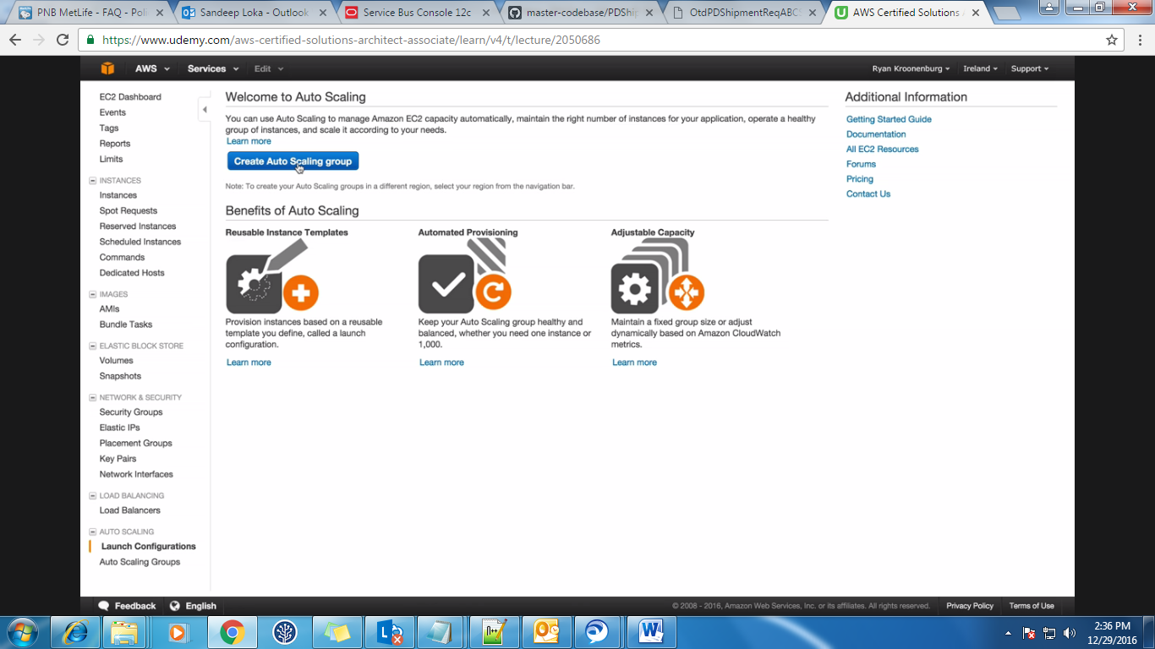Here also you can give your bootstrap scripts.

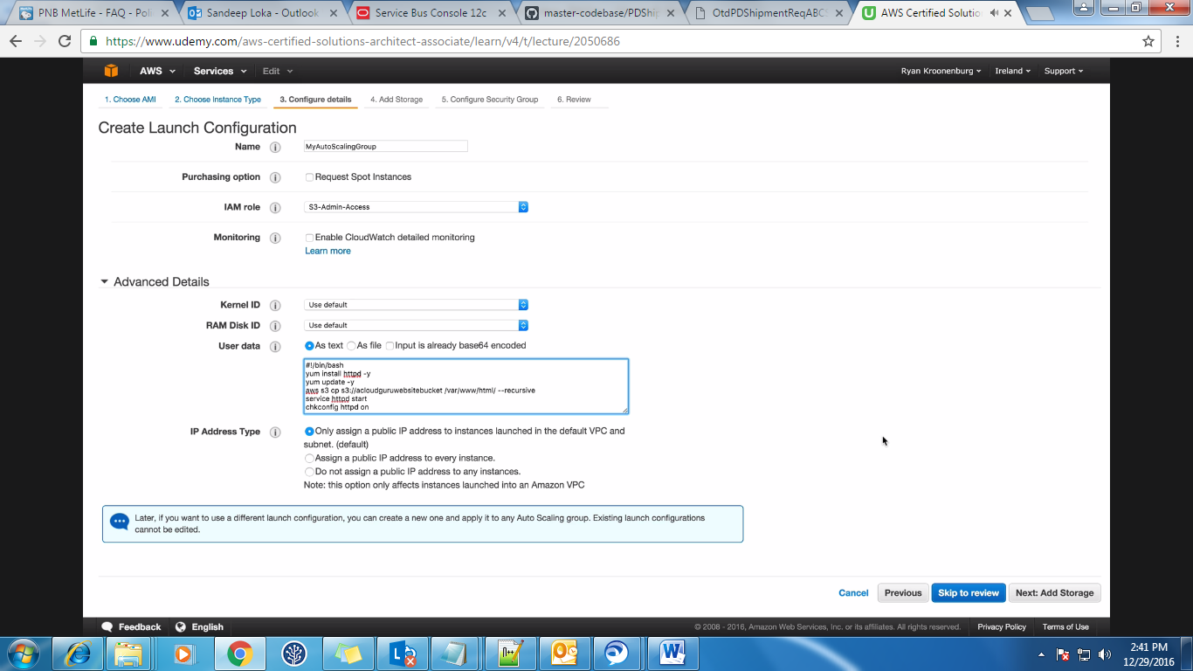After creating Launch Configuration, now create the Auto Scaling Group.   
If you choose 1 availability zone (subnet) then autoscaling group will be created under that zone only and if this zone itself is down then the downtime will be there. It is better to choose all availability zones. Here we are giving 3 instances and for these 3 instances, we have 3 subnets. You can use 1 subnet also for 3 instances but

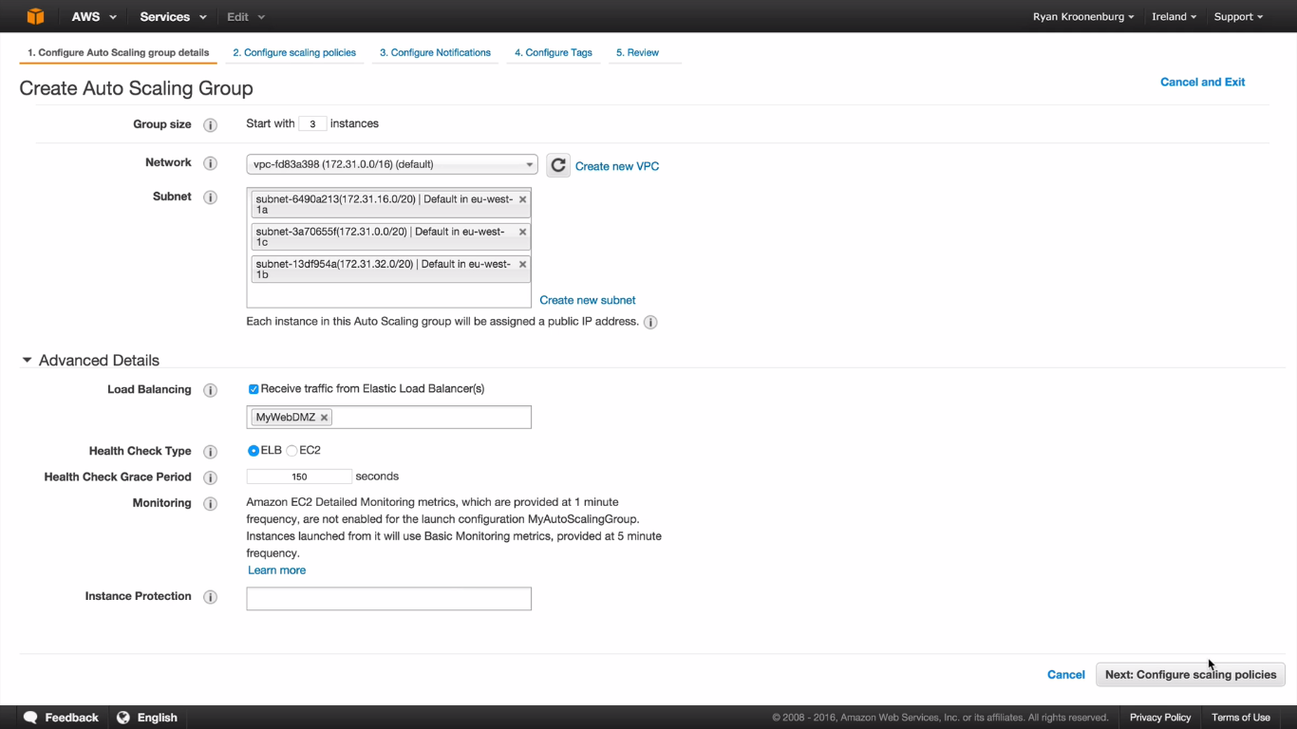

**Video 40:**

**EC2 placement Groups:**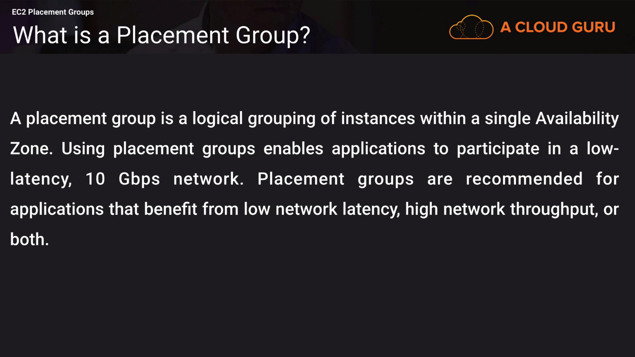

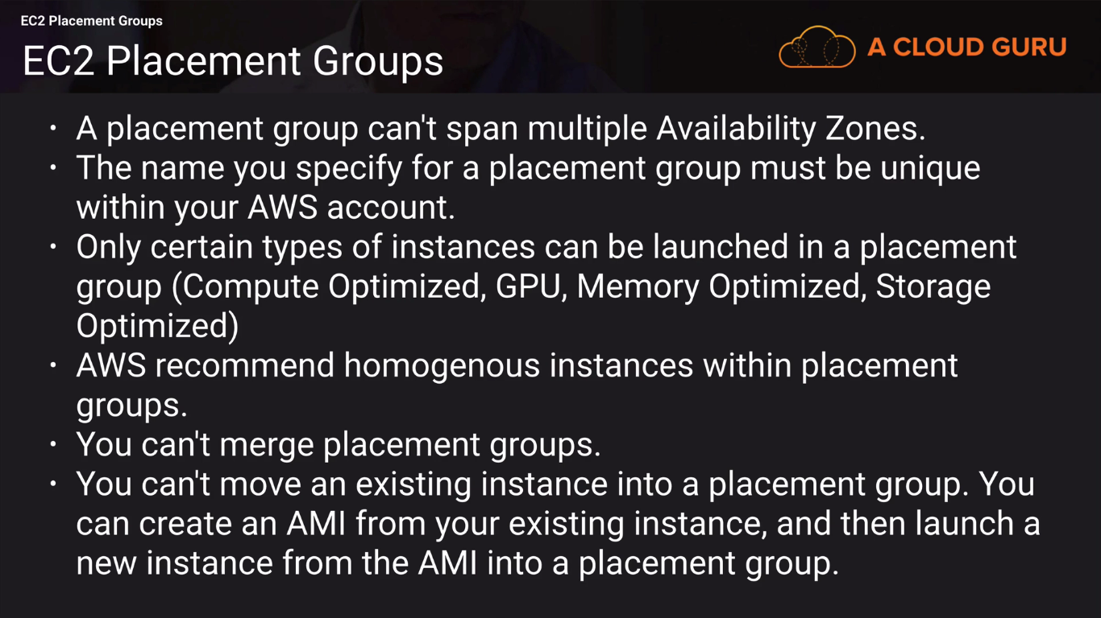 **Video 41:**

**EFS Concepts & Lab:**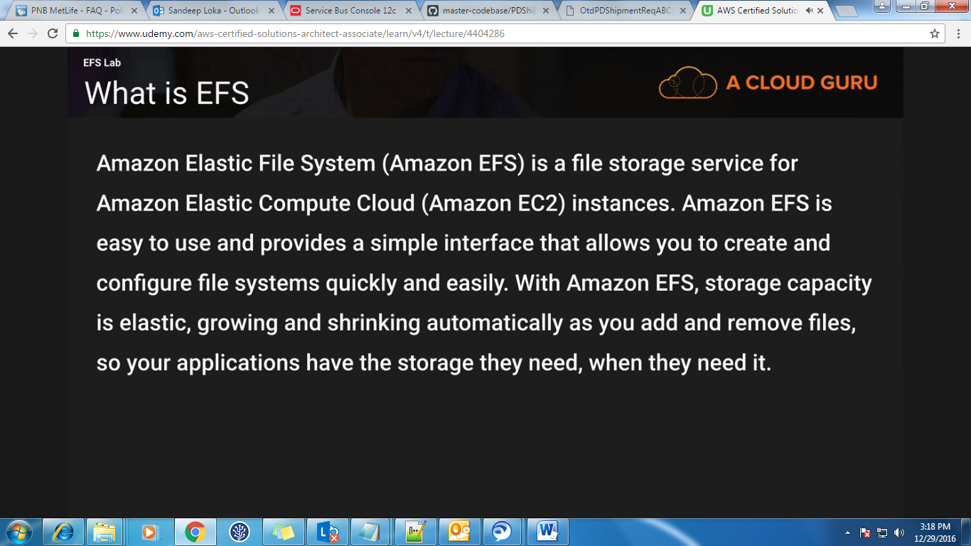  
EFS is block based storage whereas S3 is object based storage.   
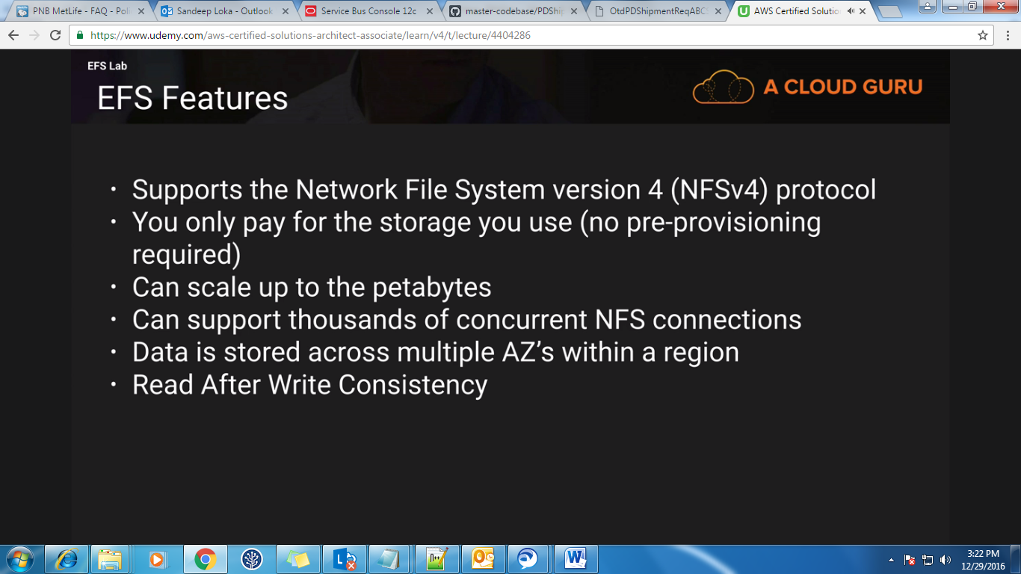  
You can see EFS under Storage & Content Delivery. It is still under preview mode and it is only available in US West (Oregon) Region.  
AZ—Availability Zones.

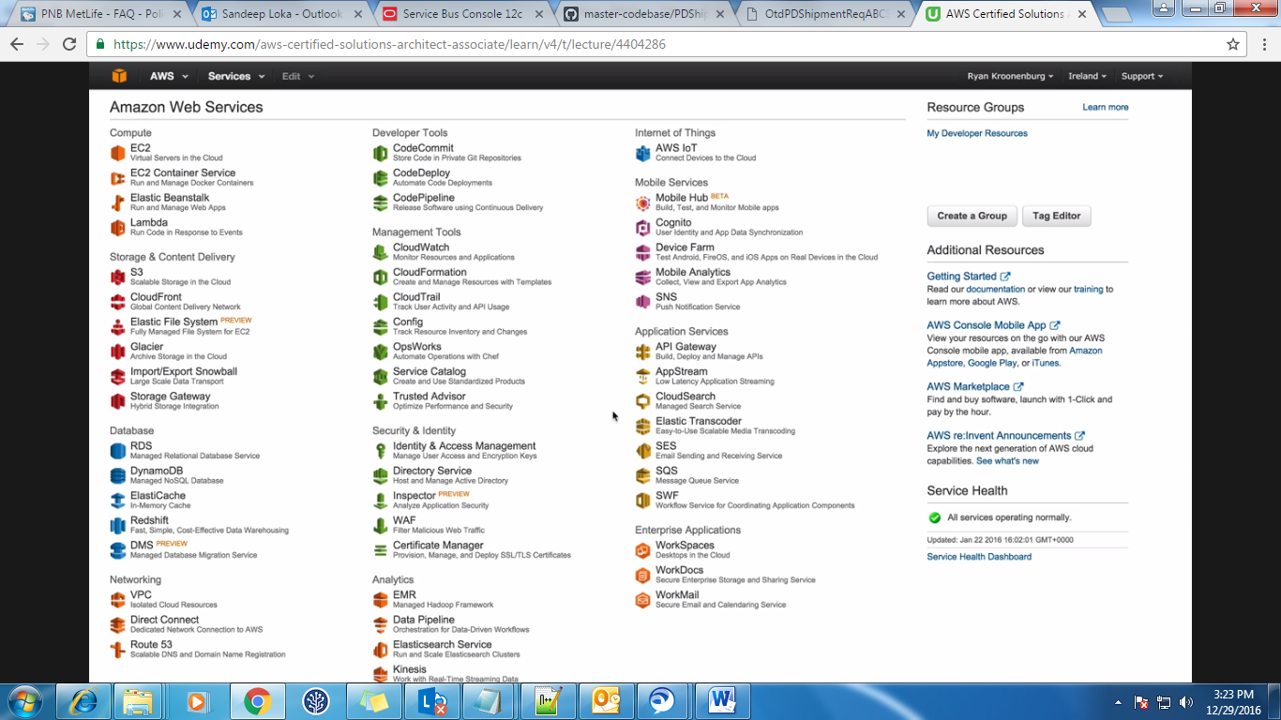Click on EFS and in step 1 keep the default values as it is.  
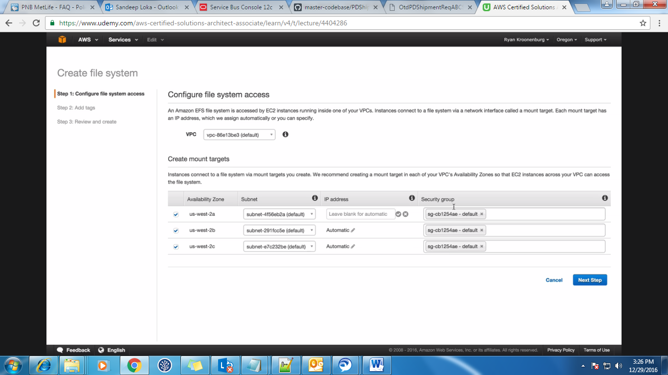  
And in the next step, give some tag and then create File System.  
After this, create 2 instances with 2 different subnets. Then create a load balancer and add these 2 instances to this load balancer. These 2 instances should have the same SG has the EFS.

After this login to terminal of these 2 instances and install apache and also start it. Then go to the root (/) directory.  
Now again go to EFS in console and click on EC2 mount instructions and there you will see the instructions on how to mount the file system.  
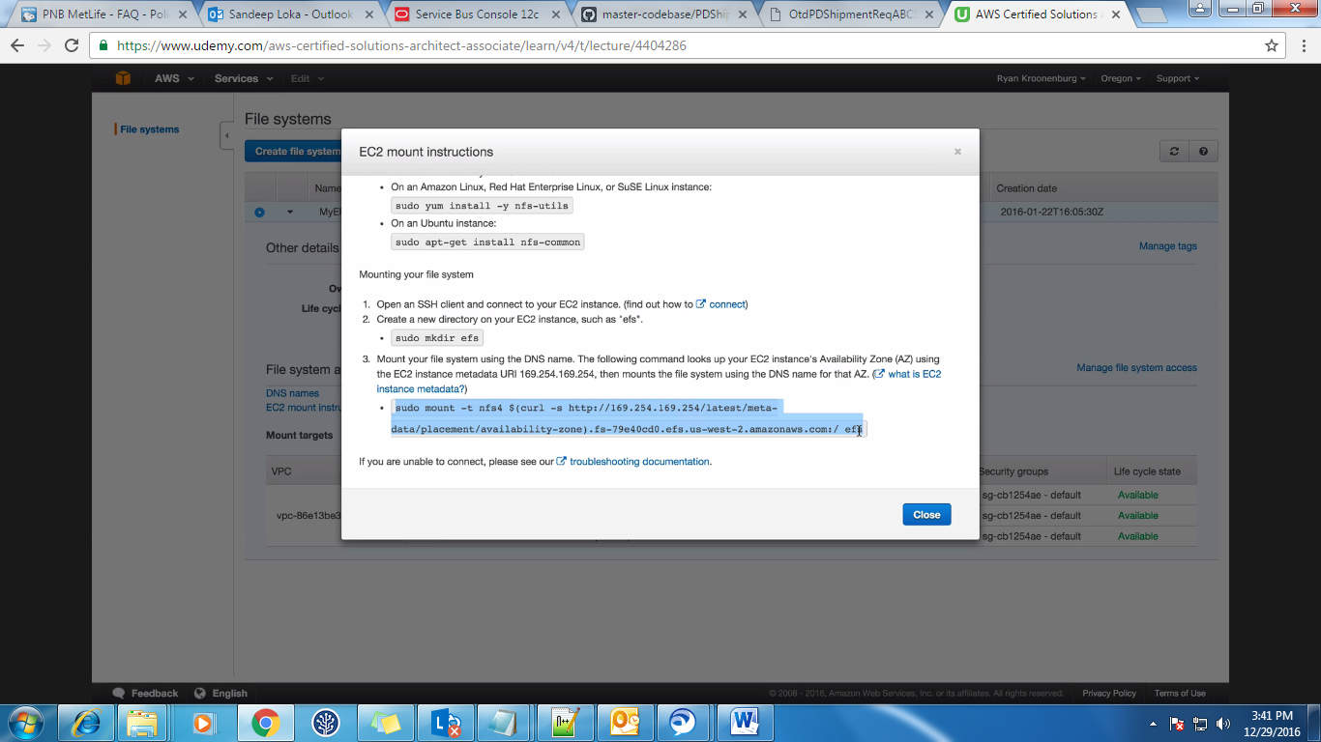  
In the above screen, they are mounting to efs but you mount it to /var/www/html. Do the same on both the instances.  
Then go to /var/www/html and create index.hml on one instance and you will see the same file created on another instance also.

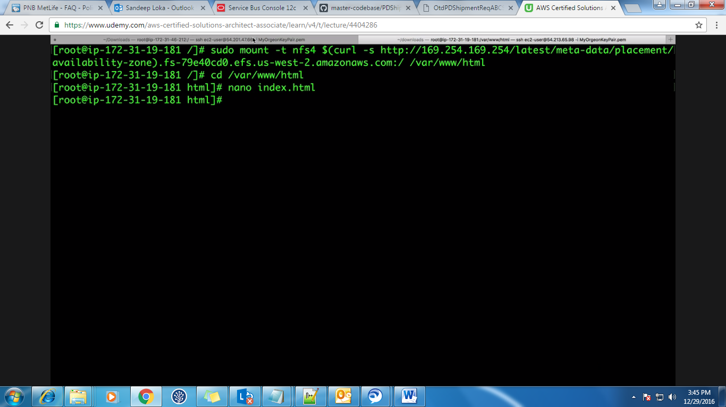If you paste the DNS of the load balancer in a browser then it should display the content in the index.html.

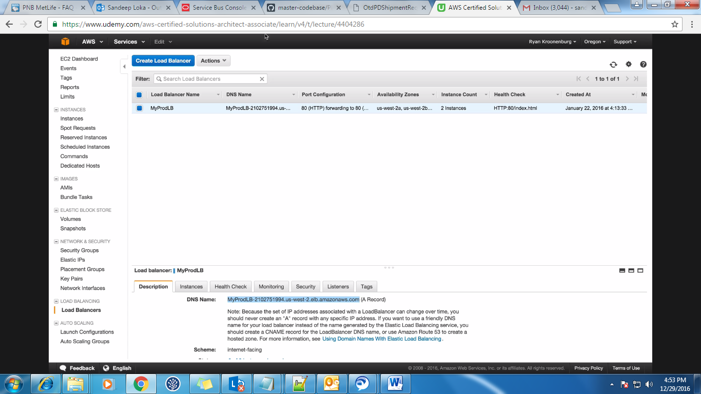In this way, whatever the content we have on one instance can be copied to different instances just by mounting the file system.

**Video 42:**

**Lambda:   
Note:** Lambda may replace EC2 in future.  
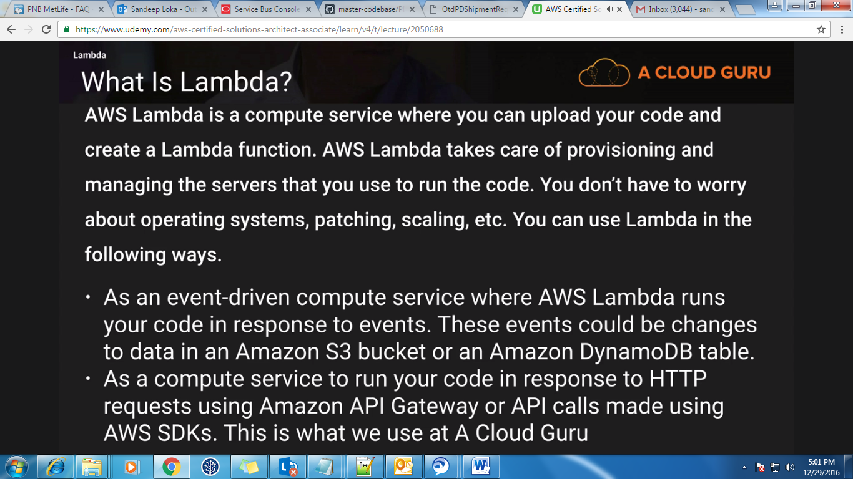

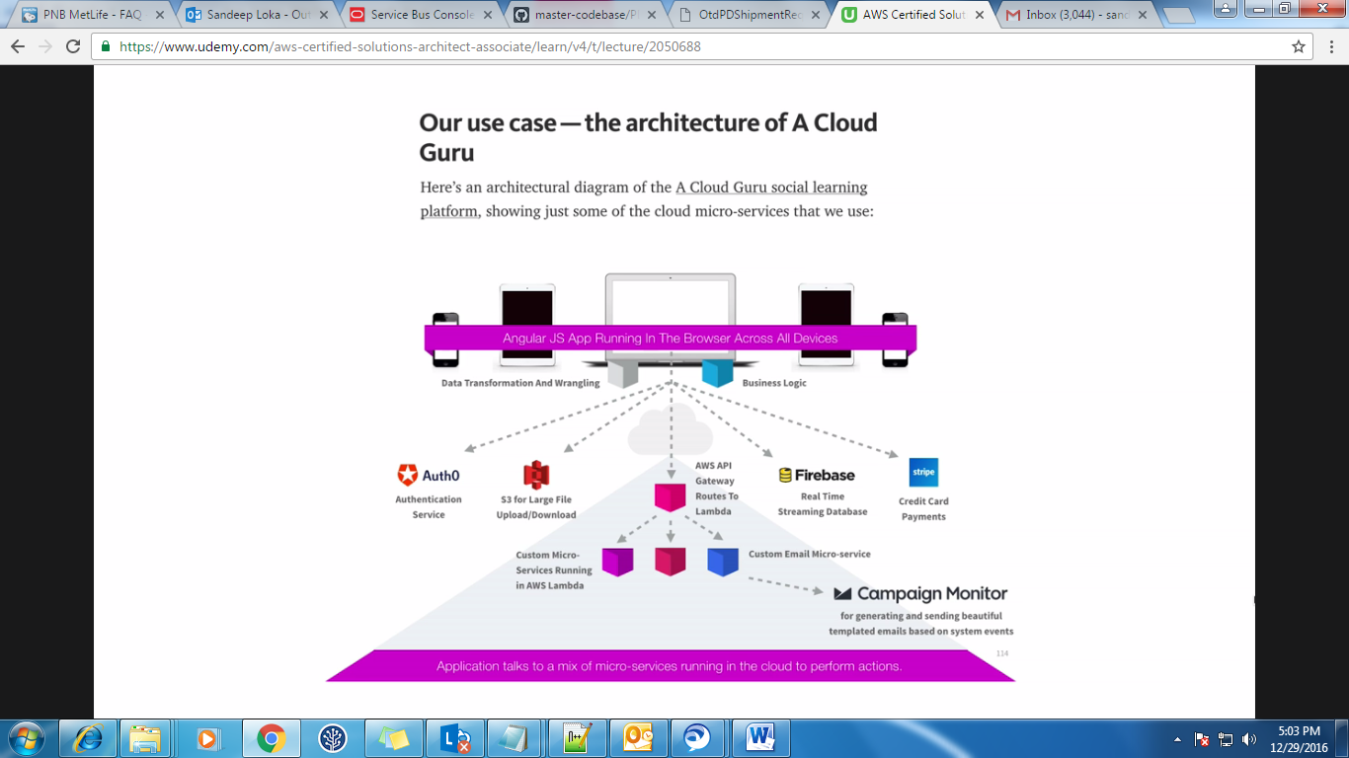

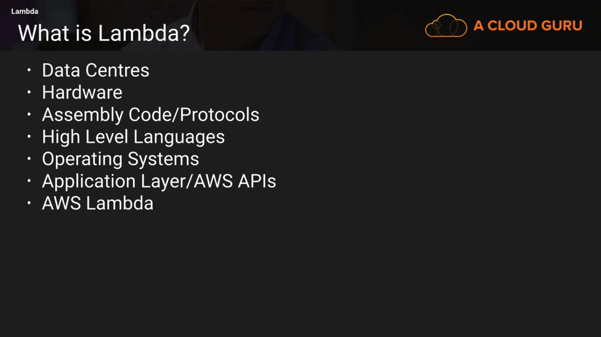

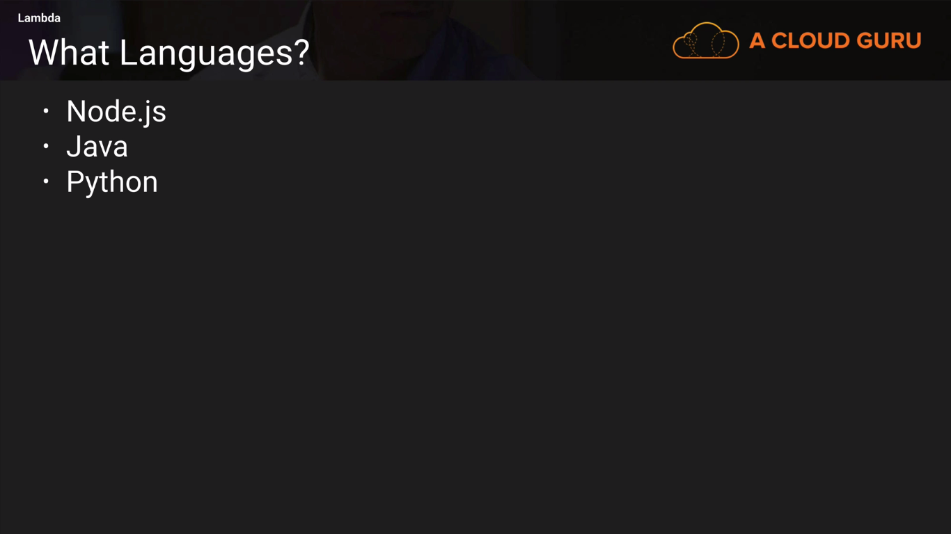

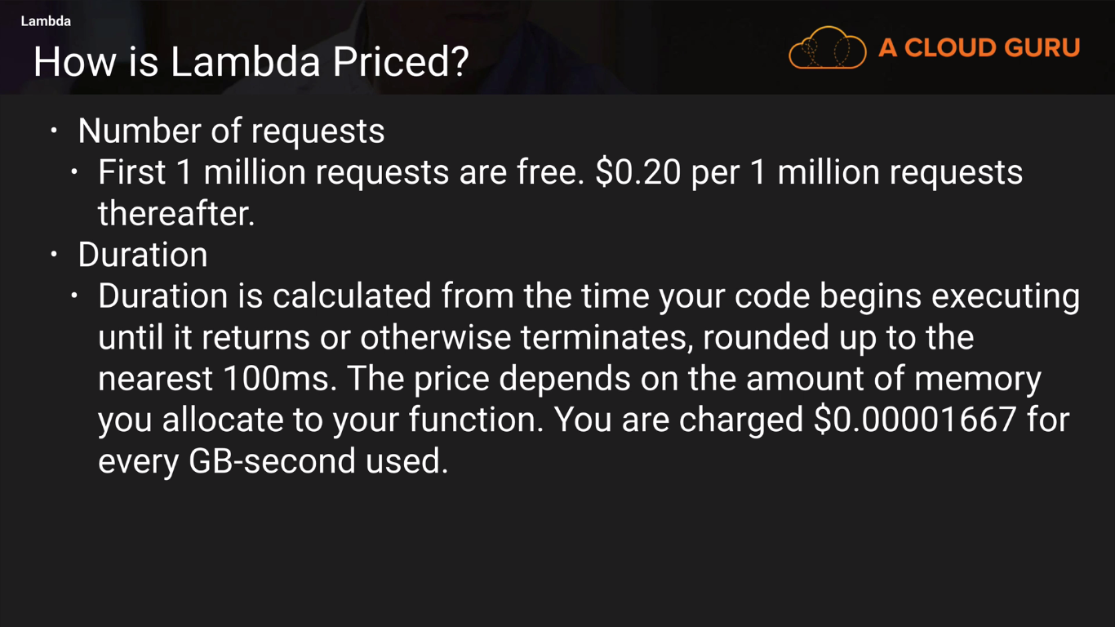

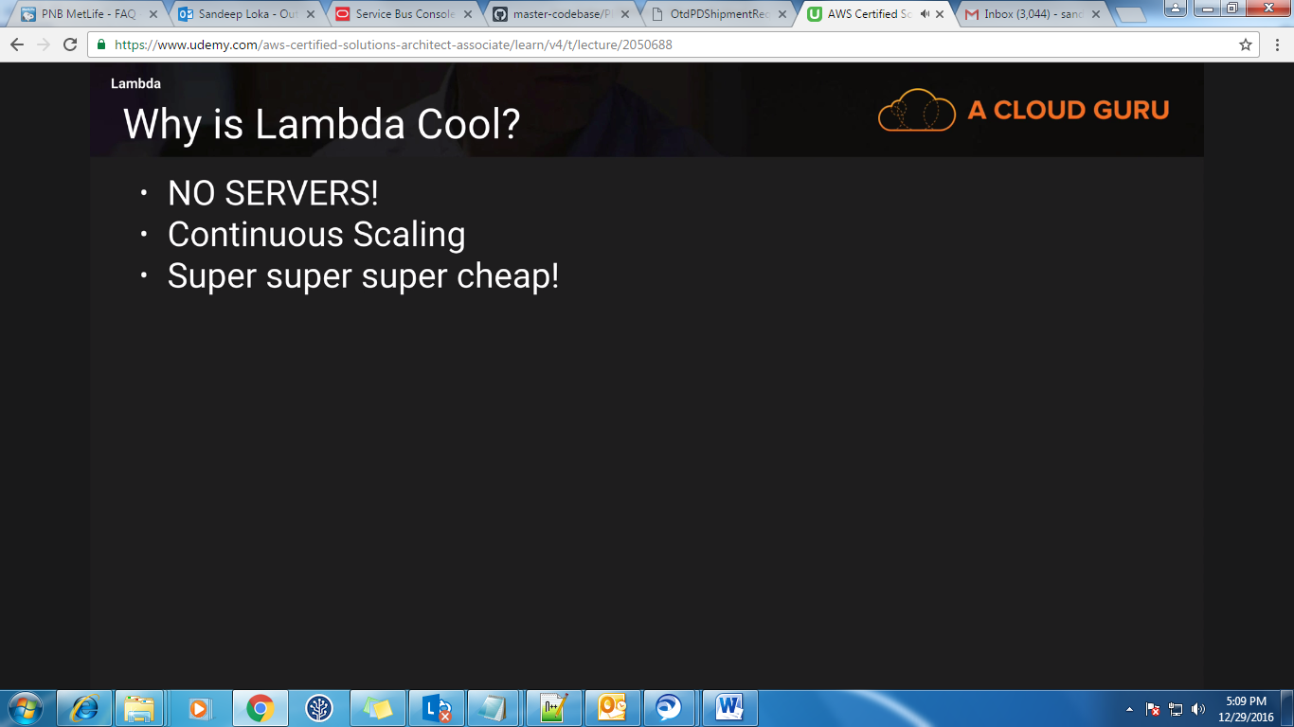

**Video 43:**

**EC2 Summary:**

